บทที่4
โปรแกรม Client/Server Implementation

- แสดงขั้นตอนการทำงาน ของ TCP Server Program บน Unix
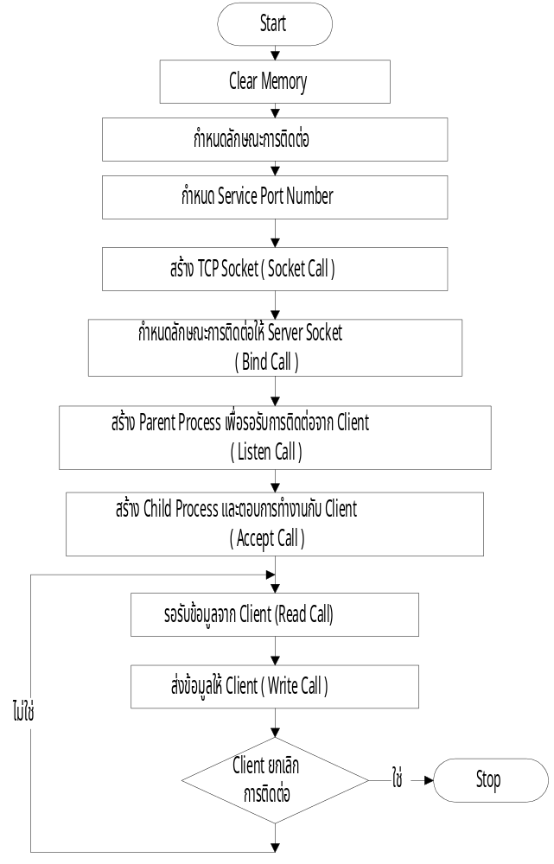

รูปที่4.1 Flowchart แสดงขั้นตอนการทำงานของ TCP Server Program บน Unix

โปรแกรม TCP Server บน Unix

/* Stream socket for server implement */
#include<sys/types.h>
#include<sys/socket.h>
#include<netinet/in.h>
#include<signal.h>
#include<stdio.h>
#include<netdb.h>
/* Declare Variable */
int s, ls; /* connected and listen socket descriptor */
struct hostent *client_name; /* pointer to host information for remote hosts */
struct servent *service_port; /* pointer to services information */
long timevar; /* contains time returns by time() */
char *ctime(); /* declare time formatting routine */
struct linger linger; /* graceful close used setting SO-LINGER */
struct sockaddr_in myaddr_in; /* for local socket address */
struct sockaddr_in peeraddr_in; /* for peer socket address */

#define BUFLEN 1024 /* size of buffer */
main(argc, argv)
int argc;
char *argv[];
{
int addrlen;
/* clear out address structure */
memset ((char *)&myaddr_in, 0,sizeof(struct sockaddr_in));
memset ((char *)&peeraddr_in, 0,sizeof(struct sockaddr_in));
/* setup address structure for socket */
myaddr_in.sin_family = AF_INET;
myaddr_in.sin_addr.s_addr = INADDR_ANY;
service_port = getservbyname("port_tcp", "tcp");
if(service_port == NULL){
fprintf(stderr, "%s: port_tcp not found in /etc/services \n",argv[0]);
exit(1);
}
myaddr_in.sin_port = service_port->s_port;
ls = socket(AF_INET, SOCK_STREAM, 0);
if(ls == -1){
perror(argv[0]);
fprintf(stderr, "%s: unable to listen on socket\n", argv[0]);
exit(1);
}
/* bind socket */
if(bind (ls, &myaddr_in, sizeof(struct sockaddr_in)) == -1) {
perror(argv[0]);
fprintf(stderr, "%s: unable to bind address\n",argv[0]);
exit(0);
}
/* listen socket so remote users can contact. */
if(listen(ls, 5) == -1){
perror(argv[0]);
fprintf(stderr, "%s: unable to listen on socket\n", argv[0]);
exit(1);
}

setpgrp(); /* set parent process */
/* fork new process for new client connecting */
switch(fork()) {
case -1:
perror(argv[0]);
fprintf(stderr, "%s: unable to fork daemon\n", argv[0]);
exit(1);
case 0:
fclose(stdin);
fclose(stderr);
signal(SIGCLD, SIG_IGN);
for(;;) {
addrlen = sizeof(struct sockaddr_in);
/*Accept call will be block until
*a new connection arrives,
*return the address of peer connecting.
*/
s = accept(ls, &peeraddr_in, &addrlen);
if( s == -1) exit(1);
switch(fork()) {
case -1:
exit(1);
case 0: /* Child process come here */
server();
exit(0);
/* Child process out of file descriptor space
* to close the new accept socket.
*/
default:
close(s);
}

}
default: /*parent process come here. */
exit(0);
}
}
/* Server procedure handle the new process from
* accept socket connecting from remote client.
*/
server()
{
int reqcnt = 0; /* keeps count of request */
char buf[BUFLEN]; /* buffer keeps data 1024 bytes */
char *inet_ntoa();
char *hostname; /* points to the remote hosts name */
int len, len1;
/* close the listen socket */
close(ls);
/* Search Internet address from the remote client
*by peer socket .
*/
client_name = gethostbyaddr((char *) &peeraddr_in.sin_addr,
sizeof(struct in_addr),
peeraddr_in.sin_family);
if(client_name == NULL) {
hostname = inet_ntoa(peeraddr_in.sin_addr);
} else {
hostname = client_name->h_name;
}
time (&timevar);
printf("Connect from %s CLIENT on port %u at %s",
hostname, ntohs(peeraddr_in.sin_port), ctime(&timevar));
/* Set socket close ,when data sent on finish */
linger.l_onoff = 1;
linger.l_linger =1;
if(setsockopt(s, SOL_SOCKET, SO_LINGER, &linger,
sizeof(linger)) == -1) {
errout: printf("connection with %s aborted on error \n", hostname);
exit(1);
}
/* When the remote client shutdown for sender, read call return zero */
while(len = read(s, buf, BUFLEN)){
if(len == -1) goto errout; /* check no success recvice */
sleep(1);
reqcnt++; /* Increment the request counter */
time(&timevar);
printf(" SERVER return %d time at %s", *buf, ctime(&timevar));
/* write call send buf return to server */
len1 = write(s, buf, BUFLEN);
if(len1 == -1) goto errout; /* return buf to client */
*buf = '\0';
}
/* close ls socket when connection finish */
close(ls);
/* print message finish */
time(&timevar);
printf("completed %s PORT %u, %d packets,TIME at %s \n",
hostname, ntohs(peeraddr_in.sin_port), reqcnt, ctime(&timevar));
}

- แสดงขั้นตอนการทำงาน ของ TCP Client Program บน Unix

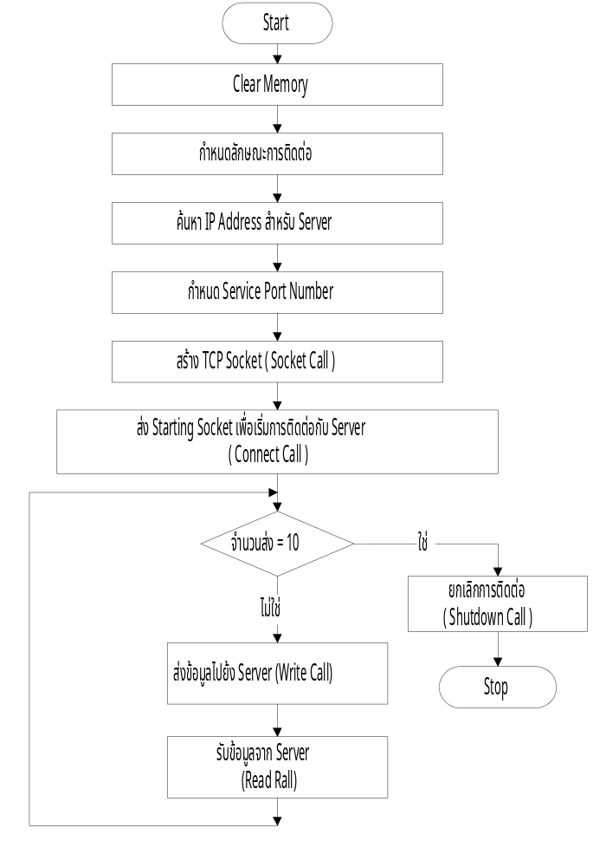

รูปที่4.2 Flowchart แสดงขั้นตอนการทำงานของ TCP Client Program บน Unix

โปรแกรม TCP Client บน Unix

/* Stream socket for client implement */
#include<sys/types.h>
#include<sys/socket.h>
#include<netinet/in.h>
#include<stdio.h>
#include<netdb.h>
int s; /* connected socket descriptor */
struct hostent *server_name; /* pointer for name's the remote host */
struct servent *service_port; /* pointer for services information */
long timevar; /* contain time return time() */
char *ctime();
struct sockaddr_in myaddr_in; /* local socket address */
struct sockaddr_in peeraddr_in; /* peer socket address */
#define BUFLEN 1024 /* size of buffer */
main(argc, argv)
int argc;
char *argv[];
{
int addrlen, i, check;
char buf[BUFLEN];
if(argc != 2) {
fprintf(stderr, "usage: %s<remote host>\n", argv[0]);
exit(2);
}
/* clear out address structure */
memset((char *)&myaddr_in, 0, sizeof(struct sockaddr_in));
memset((char *)&peeraddr_in, 0, sizeof(struct sockaddr_in));
/* Setup address structure socket for will connect */
peeraddr_in.sin_family = AF_INET;
server_name = gethostbyname(argv[1]);
if(server_name == NULL) {
fprintf(stderr, "%s: %s not found in /etc/hosts \n",
argv[0], argv[1]);
exit(1);
}
peeraddr_in.sin_addr.s_addr = ((struct in_addr *)(server_name->h_addr))->s_addr;
/* Search number port from name port */
service_port = getservbyname("port_tcp", "tcp");
if(service_port == NULL) {
fprintf(stderr, "%s: port_tcp not found in /etc/services\n",
argv[0]);
exit(1);
}
peeraddr_in.sin_port = service_port->s_port; /* get number port to endpoint */
/* create the socket */
s = socket( AF_INET, SOCK_STREAM, 0);
if(s == -1) {
perror(argv[0]);
fprintf(stderr, "%s: unable to create socket\n", argv[0]);
exit(1);
}
/* Try connect to remote server at peeraddr */
if(connect(s, &peeraddr_in, sizeof(struct sockaddr_in)) == -1) {
perror(argv[0]);
fprintf(stderr, "%s: unable to connect to remote\n", argv[0]);
exit(1);
}
addrlen = sizeof(struct sockaddr_in);
if(getsockname(s, &myaddr_in, &addrlen) == -1) {
perror(argv[0]);
fprintf(stderr, "%s: unable to read socket address\n", argv[0]);
exit(1);
}
time(&timevar);
printf("Connect to %s SERVER on port %u at %s",
argv[1], ntohs(myaddr_in.sin_port), ctime(&timevar));
sleep(2);
/* send buf and receives buf from the remote server */
for(i=1; i<=10; i++) {
*buf = i;
check = write(s, buf, BUFLEN ) ;
if( check == -1 ) {
fprintf(stderr, "%s connection aborted on error ", argv[0]);
fprintf(stderr, " on send number %d\n",i );
exit(1);
}
check = read(s, buf, BUFLEN);
if(check == -1) {
perror(argv[0]);
fprintf(stderr, "%s: errer reading result\n", argv[0]);
exit(1);
}
printf("Received result number %d\n ", *buf);
}
/* Disconnect with the remote server */
if(shutdown(s, 1) == -1) {
perror(argv[0]);
fprintf(stderr, "%s: unable to shutdown socket\n", argv[0]);
exit(1);
}
/* Print message end of connection the remote server */
time(&timevar);
printf("All done at %s", ctime(&timevar));
}

4.3 แสดงขั้นตอนการทำงาน ของ UDP Server Program บน Unix

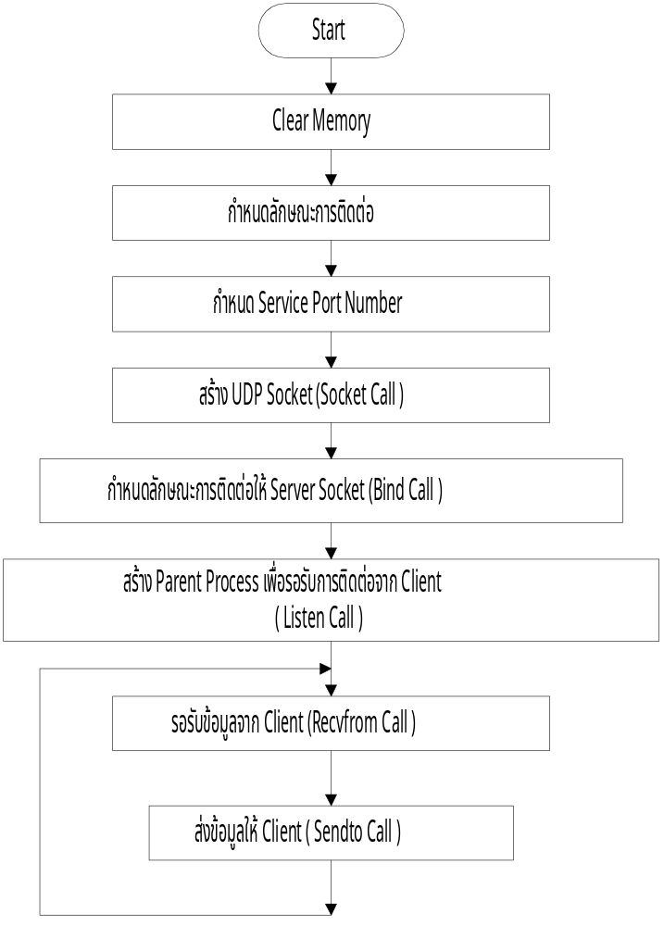

รูปที่4.3 Flowchart แสดงขั้นตอนการทำงานของ UDP Server Program บน Unix

โปรแกรม UDP Server บน Unix

/* Datagram socket server implement */
#include <sys/types.h>
#include <sys/socket.h>
#include <netinet/in.h>
#include <stdio.h>
#include <netdb.h>

int s; /* socket descriptor */
#define BUFFERSIZE 1024 /* maximum size of packets to be received */
int cc; /* contains the number of bytes read */
char buffer[BUFFERSIZE]; /* buffer for packets to be read into */
struct hostent *client_name; /* pointer host information for the remote client */
struct servent *service_port; /* pointer service information */
struct sockaddr_in myaddr_in; /* for local socket address */
struct sockaddr_in clientaddr_in; /* for client's socket address */

main(argc, argv)
int argc;
char *argv[];
{
int addrlen;
char *ctime();
long timevar; /* contain time return by time() */
char *inet_ntoa();
char *hostname; /* points to remote host's name */
/* clear out address structures */
memset ((char *)&myaddr_in, 0, sizeof(struct sockaddr_in));
memset ((char *)&clientaddr_in, 0, sizeof(struct sockaddr_in));
/* Set up address structure for the socket. */
myaddr_in.sin_family = AF_INET;
service_port = getservbyname ("port_udp", "udp");
if (service_port == NULL) {
printf("%s: port_udp not found in /etc/services\n",
argv[0]);
exit(1);
}
myaddr_in.sin_port = service_port->s_port;
/* Create the socket. */
s = socket (AF_INET, SOCK_DGRAM, 0);
if (s == -1) {
perror(argv[0]);
printf("%s: unable to create socketn", argv[0]);
exit(1);
}
/* Bind the server's address to the socket. */
if (bind(s, &myaddr_in, sizeof(struct sockaddr_in)) == -1) {
perror(argv[0]);
printf("%s: unable to bind address\n", argv[0]);
exit(1);
}
setpgrp(); /* set parent process */
switch (fork()) { /* Get new process for parent process */
case -1: /* Unable to fork, for some reason. */
perror(argv[0]);
printf("%s: unable to fork daemon\n", argv[0]);
exit(1);
case 0: /* The child process (daemon) comes here. */
/* Close stdin, stdout, and stderr so that they will
* not be kept open. From now on, the daemon will
* not report any error messages. This daemon
* will loop forever, waiting for requests and
* responding to them.
*/
close(stdin);
close(stdout);
close(stderr);
/* This will open the /etc/hosts file and keep
* it open. This will make accesses to it faster.
*/
sethostent(1);
for(;;) {
addrlen = sizeof(struct sockaddr_in);
/* Recvfrom call will block until
* new the remote client connect
* arrives,return the address
* of client on clientaddr_in pointer
* and end of buffer on cc integer.
*/
cc = recvfrom(s, buffer, BUFFERSIZE - 1, 0,
&clientaddr_in, &addrlen);
if ( cc == -1) exit(1);
/* Search the remote name from /etc/hosts */
client_name = gethostbyaddr((char *)&clientaddr_in.sin_addr,
sizeof(struct in_addr),
clientaddr_in.sin_family);
if( client_name == NULL) {
hostname = inet_ntoa(clientaddr_in.sin_addr);
} else {
hostname = client_name->h_name;
}
/* Make null terminated in buffer */
buffer[cc]='\0';
sleep(1);
time(&timevar);
printf(" Request from %s message<%s> at %s",
hostname, buffer, ctime(&timevar));
sendto (s, buffer, BUFFERSIZE,
0, &clientaddr_in, addrlen);
}

default: /* Parent process comes here. */
exit(0);
}
}

4.4 แสดงขั้นตอนการทำงาน ของ UDP Client Program บน Unix

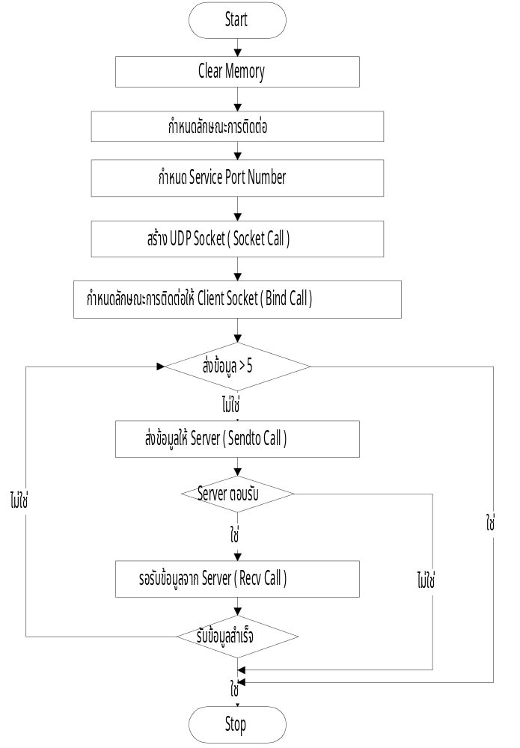

รูปที่4.4 Flowchart แสดงขั้นตอนการทำงานของ UDP Client Programบน Unix

โปรแกรม UDP Client บน Unix

/* Datagram socket for client implement */
#include <sys/types.h>
#include <sys/socket.h>
#include <sys/errno.h>
#include <netinet/in.h>
#include <stdio.h>
#include <signal.h>
#include <netdb.h>

extern int errno;
int s; /* socket descriptor */
struct hostent *server_name; /* pointer to host information for name server host */
struct servent *service_port; /* pointer to service information */
struct sockaddr_in myaddr_in; /* for local socket address */
struct sockaddr_in servaddr_in; /* for server socket address */
#define RETRIES 5 /* number of times to retry before give up */
#define BUFFERSIZE 1024 /* maximum size of packet to be read into */
char buffer[BUFFERSIZE]; /* buffer for packet to be read into */
/*
* H A N D L E R
*
* This routine is the signal handler for the alarm signal.
* It simply re-installs itself as the handler and returns.
*/
handler()
{
signal(SIGALRM, handler);
}

main(argc, argv)
int argc;
char *argv[];
{
int i;
int retry = RETRIES; /* holds the retry count */
char *inet_ntoa();
if (argc != 3) {
fprintf(stderr, "Usage: %s <nameserver> <message> \n", argv[0]);
exit(1);
}
/* clear out address structures */
memset ((char *)&myaddr_in, 0, sizeof(struct sockaddr_in));
memset ((char *)&servaddr_in, 0, sizeof(struct sockaddr_in));
/* Set up the server address. */
servaddr_in.sin_family = AF_INET;
/* Get the host information for the server's host name */
server_name = gethostbyname (argv[1]);
if ( server_name == NULL) {
fprintf(stderr, "%s: %s not found in /etc/hosts\n",
argv[0], argv[1]);
exit(1);
}
servaddr_in.sin_addr.s_addr = ((struct in_addr *)(server_name->h_addr))->s_addr;
/* Search port number from /etc/services */
service_port = getservbyname ("port_udp", "udp");
if (service_port == NULL) {
fprintf(stderr, "%s: port_udp not found in /etc/services\n",
argv[0]);
exit(1);
}
servaddr_in.sin_port = service_port->s_port;
/* Create the socket. */
s = socket (AF_INET, SOCK_DGRAM, 0);
if (s == -1) {
perror(argv[0]);
fprintf(stderr, "%s: unable to create socket\n", argv[0]);
exit(1);
}
/* Bind socket to some local address so that the
* server can send the reply back. A port number
* of zero will be used so that the system will
* assign any available port number. An address
* of INADDR_ANY will be used so we do not have to
* look up the Internet address of the local host.
*/
myaddr_in.sin_family = AF_INET;
myaddr_in.sin_port = 0;
myaddr_in.sin_addr.s_addr = INADDR_ANY;
if (bind(s, &myaddr_in, sizeof(struct sockaddr_in)) == -1) {
perror(argv[0]);
fprintf(stderr, "%s: unable to bind socket\n", argv[0]);
exit(1);
}
/* Set up alarm signal handler. */
signal(SIGALRM, handler);
/* Send the request to the nameserver. */
again: if (sendto (s, argv[2], strlen(argv[2]), 0, &servaddr_in,
sizeof(struct sockaddr_in)) == -1) {
perror(argv[0]);
fprintf(stderr, "%s: unable to send request\n", argv[0]);
exit(1);
}
/* Set up a time-out so I don't hang in case the packet
* gets lost. After all, UDP does not guarantee
* delivery.
alarm(5);
/* Wait for the reply to come in. We assume that
* no messages will come from any other source,
* so that we do not need to do a recvfrom nor
* check the responder's address.
if (recv (s, &buffer, BUFFERSIZE, 0) == -1) {
if (errno == EINTR) {
/* Alarm went off and aborted the receive.
* Need to retry the request if we have
* not already exceeded the retry limit.
*/
if (--retry) {
goto again;
} else {
printf("Unable to get response from");
printf(" %s after %d attempts.\n",
argv[1], RETRIES);
exit(1);
}
} else {
perror(argv[0]);
fprintf(stderr, "%s: unable to receive response\n",
argv[0]);
exit(1);
}
}
alarm(0);
printf(" Echo message < %s > from server\n",buffer);
}

4.5 แสดงขั้นตอนการทำงาน ของ TCP & UDP Client Program บน PC

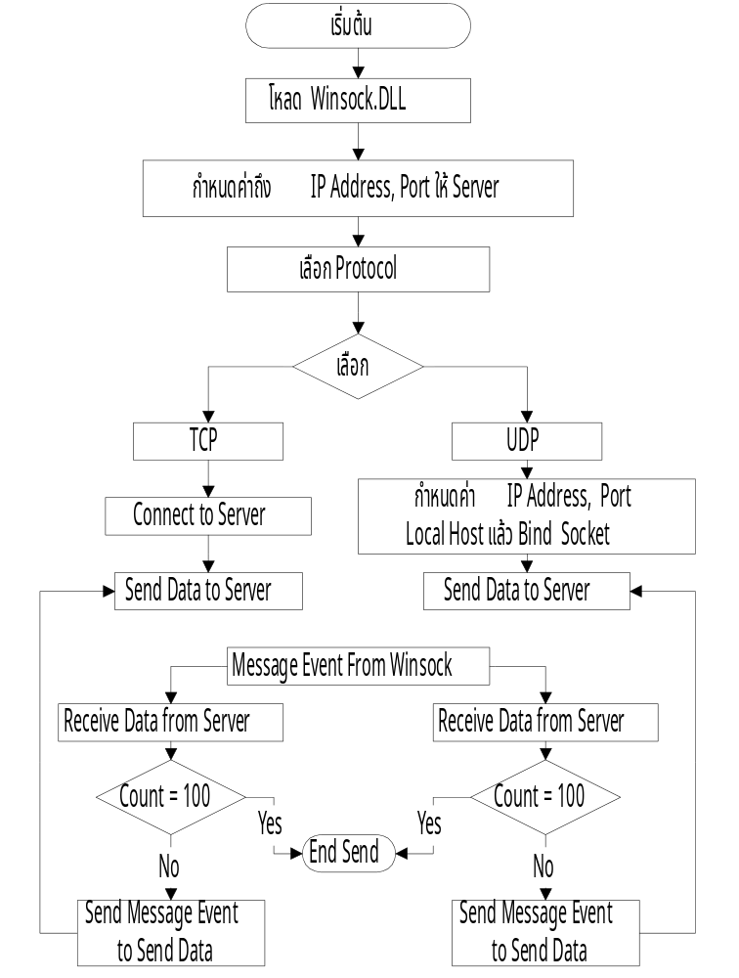

รูปที่4.5 Flowchart แสดงขั้นตอนการทำงานของ TCP & UDP Client Program บน PC

โปรแกรม TCP & UDP Client บน PC

Unit UClient;
interface
{ Identifies all units used by the program. }
uses
Windows, Messages, SysUtils, Classes, Graphics, Controls, Forms, Dialogs,
Menus, StdCtrls, ExtCtrls, Winsock;

{ The Constant reserved word defines an identifier whose value
cannot change within the block containing the declaration }
Const MaxBuffer = 1024; { Max Buffer }
WM_WINSOCKTCP = WM_USER + 1; { WinSock Event In TCP Type }
WM_WINSOCKUDP = WM_USER + 2; { WinSock Event In UDP Type }
WM_SENDTCP = WM_USER + 3; { Message Event Send In TCP Type }
WM_SENDUDP = WM_USER + 4; { Message Event Send In UDP Type }
WM_SETCURSOR = WM_USER + 5; { Message Event Set Cursor }

{A type declaration specifies an identifier that denotes a type.
A variable's type defines the set of values it can have and the
operations that can be performed on it. }
type
TFClient = class(TForm)
Memoshow: TMemo;
MainMenu: TMainMenu;
SelectProtocol: TMenuItem;
RemoteSystem: TMenuItem;
Exit1: TMenuItem;
Panel1: TPanel;
Editsend: TEdit;
Label1: TLabel;
MTCP: TMenuItem;
TCP1: TMenuItem;
UDP1: TMenuItem;
MUDP: TMenuItem;
Exit2: TMenuItem;
CreateTCP: TMenuItem;
ConnectTCP: TMenuItem;
BindUDP: TMenuItem;
DisconnectTCP: TMenuItem;
CloseSocketUDP: TMenuItem;

procedure TCP1Click(Sender: TObject); { Select TCP Protocol }
procedure UDP1Click(Sender: TObject); { Select UDP Protocol }
procedure Exit1Click(Sender: TObject);
procedure FormActivate(Sender: TObject);
procedure RemoteSystemClick(Sender: TObject);
procedure FormClose(Sender: TObject; var Action: TCloseAction);
procedure CreateTCPClick(Sender: TObject);
procedure ConnectTCPClick(Sender: TObject);
procedure DisconnectTCPClick(Sender: TObject);
procedure BindUDPClick(Sender: TObject);
procedure EditsendKeyPress(Sender: TObject; var Key: Char);
procedure CloseSocketUDPClick(Sender: TObject);
private
{ Private declarations }
Sd_UDP,Sd_TCP: TSocket; { Connected socket descriptor }
{ SockAddrIn structure is specification for Internet address family
Use to assign the components of an Internet Address }
SAddr_Loc, SockAddr: PSockAddrIn;
SAddr_to, SAddr_From: PSOCKAddrIn;
{ A pointer to the WSADATA data structure that is to
receive details of the Windows Sockets implementation. }
WSData: TWSAData;
Version: Word; { Version of Winsock.DLL }

{ Data Buffer For Send & Receive }
BufferTCP, BufferUDP: Array[0..MaxBuffer-1] Of Char;
ResultTCP, ResultUDP, LenBufferUDP: Integer; { Return Result from function }
CountSendTCP, CountSendUDP: Integer; { Counter For Send Data TCP & UDP }
TextTCP, TextUDP: String; { Save Text From EditSend.Text }
HostTCP,HostUDP: PHOSTENT; { Keep Address & Name Structure }
SHostTCP, SHostUDP: String; { Keep Server Name }

Procedure CheckErrorCode(Text: String);
{ Windows Message For Event TCP From Winsock }
Procedure EventTCP(Var M: TMessage); Message WM_WINSOCKTCP;
{ Windows Message For Event UDP From Winsock }
Procedure EventUDP(Var M: TMessage); Message WM_WINSOCKUDP;
{ Windows Message For Send Event TCP }
procedure SendDataTCP(Var M: TMessage); Message WM_SENDTCP;
{ Windows Message For Send Event UDP }
procedure SendDataUDP(Var M: TMessage); Message WM_SENDUDP;
{ Windows Message For Set Cursor }
Procedure SetCursorX(VAr M: TMessage); Message WM_SETCURSOR;
public
{ Public declarations }
{ Variable Save Value IP ADDRESS and PORT }
IP_Text, Port_Text : String;
End;

var
{ Declaration Type to FClient }
FClient: TFClient;
{ The implementation part of a unit defines the block of all public procedures }
implementation
Uses URemote;
{$R *.DFM}

procedure TFClient.TCP1Click(Sender: TObject); { Select TCP protocol }
begin
IF Not TCP1.Checked Then { Indicates whether the check menu is selected }
Begin
{ TCP1 MenuItem is Selected }
{ Enabled MTCP MenuItem controls whether the control
responds to mouse, keyboard, and timer events. }
TCP1.Checked := True;
MTCP.Enabled := True;
{*********************}
{ UDP1 MenuItem is UnSelected }
{ Disabled MUDP MenuItem controls whether the control
responds to mouse, keyboard, and timer events. }
UDP1.Checked := False;
MUDP.Enabled := False;
end;
end;

procedure TFClient.UDP1Click(Sender: TObject); { Select UDP protocol }
begin
IF Not UDP1.Checked Then { Indicates whether the check menu is selected }
begin
{ UDP1 MenuItem is Selected }
{ Enabled MUDP MenuItem controls whether the control
responds to mouse, keyboard, and timer events. }
UDP1.Checked := True;
MUDP.Enabled := True;
{**********************}
{ TCP1 MenuItem is UnSelected }
{ Disabled MTCP MenuItem controls whether the control
responds to mouse, keyboard, and timer events. }
TCP1.Checked := False;
MTCP.Enabled := False;
end;
end;

procedure TFClient.Exit1Click(Sender: TObject); { Close All Application }
begin
{ Closes a sockets. it releases the socket descriptor }
IF DisConnectTCP.Enabled Then ResultTCP := CloseSocket(Sd_TCP);
IF CloseSocketUDP.Enabled Then ResultUDP := CloseSocket(Sd_UDP);
{ Releases memory allocated for a dynamic variable. }
Dispose(SockAddr);
Dispose(SAddr_Loc);
Dispose(SAddr_to);
Dispose(SAddr_From);
Close; { Close All Application }
end;

procedure TFClient.FormActivate(Sender: TObject); { Start Application }
begin
{ Create Pointer to Variable }
New(SockAddr);
New(SAddr_Loc);
New(SAddr_to);
New(SAddr_From);
Version := MAkeword(1,1);
ResultTCP := WSAStartUp(Version, WsData); { Load Winsock.Dll }
If ResultTCP = 0 Then { WsaStartUp Successful }
begin
{ Show Description Winsock.DLL }
MemoShow.Lines.Add('Start Load.. Winsock.DLL OK');
MemoShow.Lines.Add(WsData.szDescription);
MemoShow.Lines.Add(WsData.szSystemStatus);
end Else
begin
MemoShow.Lines.Add('Start.. Can not Load Winsock.DLL ');
end;
end;
procedure TFClient.RemoteSystemClick(Sender: TObject);
begin
{ Show a form *FRemote* as a modal form. }
FRemote.Showmodal;
end;

procedure TFClient.FormClose(Sender: TObject; var Action: TCloseAction);
begin
{ The Windows Sockets WSACleanup function
terminates use of the Windows Sockets DLL. }
WSACleanup();
end;

procedure TFClient.CreateTCPClick(Sender: TObject);
Var IPAddress: Array[0..20] of Char;
Begin
{ The Windows Sockets socket function creates a TCP socket .
If the function succeeds, socket returns a descriptor referencing the new socket.
If the function fails, a value of INVALID_SOCKET is returned }
Sd_TCP := Socket(PF_INET, SOCK_STREAM, 0);
If Sd_TCP = INVALID_SOCKET Then CheckErrorCode('Create')
Else
begin
MemoShow.Lines.Add('TCP Create Socket OK ');
StrPCopy(IPAddress,IP_Text);
{ Set IP Address, Port for TSockAddrIn Structure To SockAddr Variable }
SockAddr.sin_family := PF_INET;
SockAddr.sin_addr.s_addr := Inet_Addr(IPAddress); { IP Server }
SockAddr.sin_port := htons(StrtoInt(Port_Text)); { Port Server }
end;
end;

procedure TFClient.CheckErrorCode(Text: String); { Check error Code }
Var ErrorCode: Integer;
S: String;
Begin
S := '';
{ Gets the error status for the last operation that failed. }
ErrorCode := WsaGetLastError();
Case ErrorCode OF
WSAEADDRNOTAVAIL: {10049}
S := 'The specified address is not available from the local computer.';
WSAECONNREFUSED: {10061}
S := 'The attempt to connect was forcefully rejected.';
WSAENOTSOCK: {10038}
S := 'The descriptor is not a socket.';
End;
If S <> '' Then S := ' *' + S + '*';
S := InttoStr(ErrorCode) + ': ERROR ' + Text + S;
MemoShow.Lines.Add(S);
end;

procedure TFClient.ConnectTCPClick(Sender: TObject);
begin
{ Local Connect to Server }
SendMessage(Handle, WM_SETCURSOR, crHourGlass, 0); { Set HourGlass Cursor }
ResultTCP := Connect(Sd_TCP,SockAddr^,Sizeof(SockAddr^)); { Connect to Server }
SendMessage(Handle, WM_SETCURSOR, CrDefault, 0); { Set Default Cursor }
If ResultTCP = SOCKET_ERROR Then CheckErrorCode('Connect')
Else
begin
CreateTCP.Enabled := False;
ConnectTCP.Enabled := False;
DisconnectTCP.Enabled := True;
EditSend.SetFocus;
{ The Windows Sockets WSAAsyncSelect function requests event
notification for a socket. }
ResultTCP := WsAAsyncSelect(Sd_TCP,Handle,WM_WINSOCKTCP,FD_CONNECT OR FD_READ);
If ResultTCP = SOCKET_ERROR Then CheckErrorCode('WsaAsynSelect ');
end;
end;

{ Procedure Receive Message Event WM_WINSOCKTCP **TCP** }
Procedure TFClient.EventTCP(Var M: TMessage);
Begin
Case (M.LParam) Of
FD_CONNECT : { Receive notification of completed connection }
begin
SendMessage(Handle, WM_SETCURSOR, crHourGlass,0); { Set HourGlass Cursor }
{ Retrieves the hostname By IP Address from Database File (Hosts file) }
HostTCP := Gethostbyaddr(@SockAddr.sin_addr.s_addr, 4, PF_INET);
If HostTCP = Nil Then SHostTCP := Inet_ntoa(SockAddr.sin_addr)
Else SHostTCP := HostTCP.h_name;
SendMessage(Handle, WM_SETCURSOR, CrDefault, 0); { Set Default Cursor }
MemoShow.Lines.Add('CONNECT TO #' + SHostTCP + '# SERVER ...OK');
end;
FD_READ : { Receive notification of readiness for reading }
begin
BufferTCP := '';
{ Receives data from a socket. }
ResultTCP := Recv(Sd_TCP,BufferTCP,MaxBuffer,0);
If ResultTCP = SOCKET_ERROR Then CheckErrorCode('Recv')
Else MemoShow.Lines.Add('Return From Server : ' + BufferTCP);
{ Check Amount Send}
If CountSendTCP < 100 Then
begin
Inc(CountSendTCP);
{ the window procedure is called immediately as a subroutine.
If the specified window was created by a different thread,
Windows switches to that thread and calls the
appropriate window procedure. }
SendMessage(Handle,WM_SENDTCP,0,0); { Message to SendDataTCP procedure }
end Else CountSendTCP := 0;
end; {read}
end; {Case }
end;

{ Procedure Receive Message Event WM_WINSOCKUDP **UDP** }
Procedure TFClient.EventUDP(Var M: TMessage);
Begin
Case (M.LParam) Of
FD_READ : { Receive notification of readiness for reading }
begin
BufferUDP := '';
LenBufferUDP := SizeOf(SAddr_From^);
{ Receives a Datagram and stores the source address. }
ResultUDP := RecvFrom(SD_UDP,BufferUDP,MaxBuffer,0,SAddr_From^,LenBufferUDP);
If ResultUDP = SOCKET_ERROR Then CheckErrorCode('RecvFrom')
Else MemoShow.Lines.Add('Return From #' + SHostUDP + '# Server: ' + BufferUDP);
If CountSendUDP < 100 Then
begin
Inc(CountSendUDP);
SendMessage(Handle,WM_SENDUDP,0,0); { Message to SendDataUDP procedure }
end Else CountSendUDP := 0;
end; {read}
End; {Case}
End;

procedure TFClient.DisconnectTCPClick(Sender: TObject); { End Connect TCP }
begin
{ Closes a sockets. it releases the tcp socket descriptor }
ResultTCP := CloseSocket(Sd_TCP);
If ResultTCP = SOCKET_ERROR Then CheckErrorCode('CloseSocket')
Else
begin
MemoShow.Lines.Add('Disconnect OK ....');
DisconnectTCP.Enabled := False;
CreateTCP.Enabled := True;
ConnectTCP.Enabled := True;
end;
end;

{ Create,Bind Local Socket and Set Address Server }
procedure TFClient.BindUDPClick(Sender: TObject);
Var IPAddress: Array[0..20] of Char;
begin
{ The Windows Sockets socket function creates a UDP socket .
If the function succeeds, socket returns a descriptor referencing the new socket.
If the function fails, a value of INVALID_SOCKET is returned }
Sd_UDP := Socket(PF_INET, SOCK_DGRAM, 0);
If Sd_UDP = INVALID_SOCKET Then CheckErrorCode('Create')
Else
begin
MemoShow.Lines.Add('UDP Create Socket OK ');
BindUDP.Enabled := False;
CloseSocketUDP.Enabled := True;
EditSend.SetFocus;
MemoShow.Lines.Add('Create Socket OK');
{ Set Address,Port For Local Address }
SAddr_Loc.sin_family := PF_INET;
SAddr_Loc.sin_addr.s_addr := htonl(INADDR_ANY);
SAddr_Loc.sin_port := htons(0); { Assign By System }
{ Associates a local address with a socket. }
ResultUDP := Bind(Sd_UDP,SAddr_Loc^,Sizeof(SAddr_Loc^));
If ResultUDP = SOCKET_ERROR Then CheckErrorCode('Bind')
Else
begin
MemoShow.Lines.Add('UDP Bind OK');
{ Request that the Windows Sockets DLL should send a message
to the window hWnd whenever it detects any of the network events
specified by the lEvent parameter. The message that should be
sent is specified by the wMsg parameter. }
ResultUDP := WsAAsyncSelect(Sd_UDP,Handle,WM_WINSOCKUDP, FD_READ);
If ResultUDP = SOCKET_ERROR Then CheckErrorCode('WsaAsyncSelect');
end;
end;
{ Set Addr_In For Remote Machine **Server** }
StrPCopy(IPAddress,IP_Text);
SAddr_To.sin_family := PF_INET;
SAddr_To.sin_addr.s_addr := Inet_Addr(IPAddress);
SAddr_To.sin_port := htons(StrtoInt(Port_Text));;
SendMessage(Handle, WM_SETCURSOR, crHourGlass, 0); { Set HourGlass Cursor }
HostUDP := Gethostbyaddr(@SAddr_To.sin_addr.s_addr, 4, PF_INET);
{ Retrieves the hostname By IP Address from Database File (Hosts file) }
If HostUDP = Nil Then SHostUDP := Inet_ntoa(SockAddr.sin_addr)
Else SHostUDP := HostTCP.h_name;
SendMessage(Handle, WM_SETCURSOR, CrDefault, 0); { Set Default Cursor }
end;

procedure TFClient.EditsendKeyPress(Sender: TObject; var Key: Char);
Begin
If Key = Chr(13) Then { Check KeyPressed Enter }
Begin
IF TCP1.Checked Then
begin
CountSendTCP := 0;
TextTCP := EditSend.Text;
SendMessage(Handle,WM_SENDTCP,0,0); { Message to SendDataTCP procedure }
end
ELse IF UDP1.Checked Then
begin
CountSendUDP := 0;
TextUDP := EditSend.Text;
SendMessage(Handle,WM_SENDUDP,0,0); { Message to SendDataUDP procedure }
end;
end;
End;

procedure TFClient.SendDataTCP(Var M : Tmessage);
begin
StrPCopy(BufferTCP, TextTCP + Inttostr(CountSendTCP));
{ Sends data on a connected socket.}
ResultTCP := Send(SD_TCP, BufferTCP ,Length(BufferTCP) ,0);
If ResultTCP = SOCKET_ERROR Then CheckErrorCode('Send')
End;
procedure TFClient.SendDataUDP(Var M : Tmessage);
begin
StrPCopy(BufferUDP, TextUDP + Inttostr(CountSendUDP));
{ Sends data to a specific destination. }
ResultUDP := Sendto(Sd_UDP, BufferUDP, Length(BufferUDP), 0, SAddr_to^, Sizeof(SAddr_to^));
If ResultUDP = SOCKET_ERROR Then CheckErrorCode('Sendto')
end;

procedure TFClient.CloseSocketUDPClick(Sender: TObject);
begin
{ Closes a sockets. it releases the udp socket descriptor }
ResultUDP := CloseSocket(Sd_UDP);
If ResultUDP = SOCKET_ERROR Then CheckErrorCode('CloseSocket')
Else
begin
MemoShow.Lines.Add('CloseSocket UDP OK ....');
BindUDP.Enabled := True;
CloseSocketUDP.Enabled := False;
end;
end;

Procedure TFClient.SetCursorX(Var M: TMessage); { Set Cursor }
begin
EditSend.Cursor := M.WParam;
Panel1.Cursor := M.WParam;
Memoshow.Cursor := M.WParam;
FClient.Cursor := M.WParam;
end;

End. { End Program }

4.6 แสดงขั้นตอนการทำงาน ของ RPC program บน UNIX

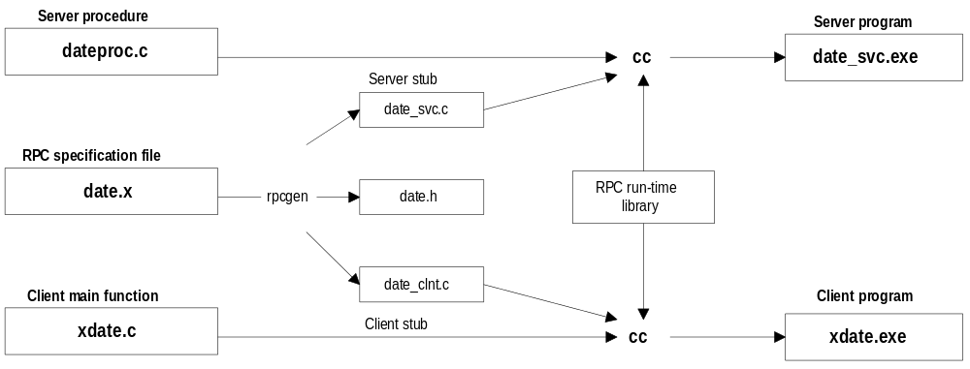

รูปที่4.6 Flowchart แสดงขั้นตอนการComplie RPC program บน UNIX

โปรแกรม RPC server procedure บน UNIX

/*
* dateproc.c - remote procedures; called by server stub.
*/

#include <rpc/rpc.h>
#include <time.h>

/*
* Return the binary date and time.
*/

long *bin_date_1(void)
{
static long timeval; /* must be static */
timeval = time((long *)0);
return(&timeval);
}

/*
* Convert a binary time and return a human readable sring.
*/

char **str_date_1(bintime)
{
long *bintime;
static char *ptr; /* must be static */
ptr = ctime(bintime);
return (&ptr);
}

โปรแกรม RPC client main function บน UNIX

/*
* xdate.c - client program for remote date service.
*/

#include <stdio.h>
#include <rpc/rpc.h>
#include "date.h"

main(int argc, char *argv[])
{
CLIENT *cl; /* RPC handle */
char *server;
long *lresult; /* return value from bin_date_1() */
char **sresult; /* return value from str_date_1() */

if ( argc != 2 ) {
fprintf(stderr, "usage: %s hostname\n", argv[0]);
exit(1);
}

server = argv[1];

/*
* Create the client "handle."
*/

if ( (cl=clnt_create(server, DATE_PROG, DATE_VERS, "udp")) == NULL ) {
/*
* Could't establish connection with server.
*/
clnt_pcreateerror(server);
exit(2);
}

/*
* First call the remote procedure "bin_date".
*/

if ( (lresult=bin_date_1(NULL,cl)) == NULL ) {
clnt_perror(cl, server);
exit(3);
}
printf("time on host %s = %ld\n", server, *lresult);

/*
* Now call the remote procedure "str_date".
*/

if ( (sresult=str_date_1(lresult,cl)) == NULL ) {
clnt_perror(cl, server);
exit(4);
}
printf("time on host %s = %s", server, *sresult);

clnt_destroy(cl);
exit(0);
}

โปรแกรม RPC specification บน UNIX

/*
* date.x - Specification of remote date and time service.
*/

/*
* Define 2 procedures:
* bin_date_1() returns the binary time and date (no auguments).
* str_date_1() takes a binary time and returns a human-readable string.
*/

program DATE_PROG {
version DATE_VERS {
long BIN_DATE(void) = 1; /* procedure number = 1 */
string STR_DATE(long) = 2; /* procedure number = 2 */
} = 1; /* version number = 1 */
} = 0x31234567; /* program number = 0x31234567 */

4.7 ผลลัพธ์การทำงานของ Client/Server
4.7.1 ผลลัพธ์การทำงานของ Client/Server แบบ TCP บน Unix

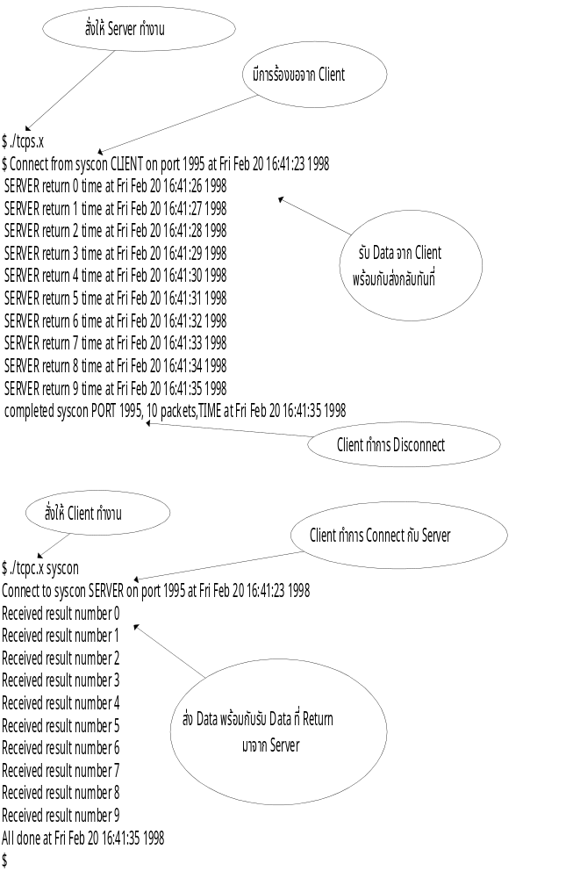
4.7.2 ผลลัพธ์การทำงานของ Client/Server แบบ UDP บน Unix

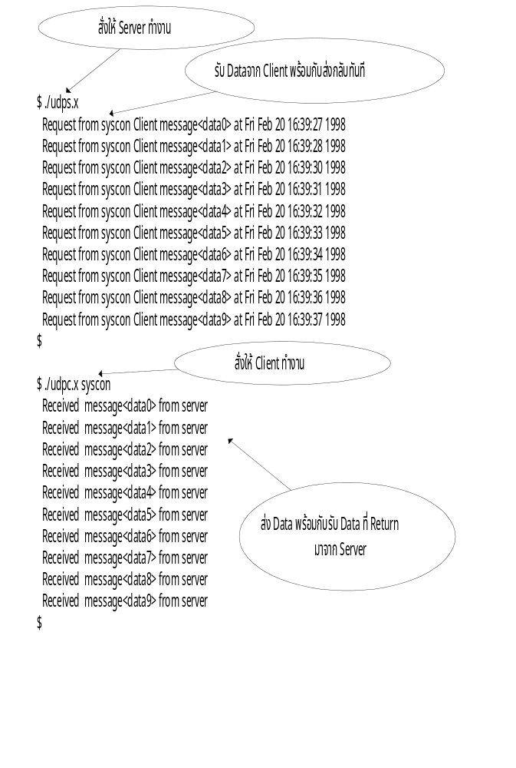
4.7.3 ผลลัพธ์การทำงานของ TCP Server บน Unix ที่เชื่อมต่อกับ TCP Client บน PC
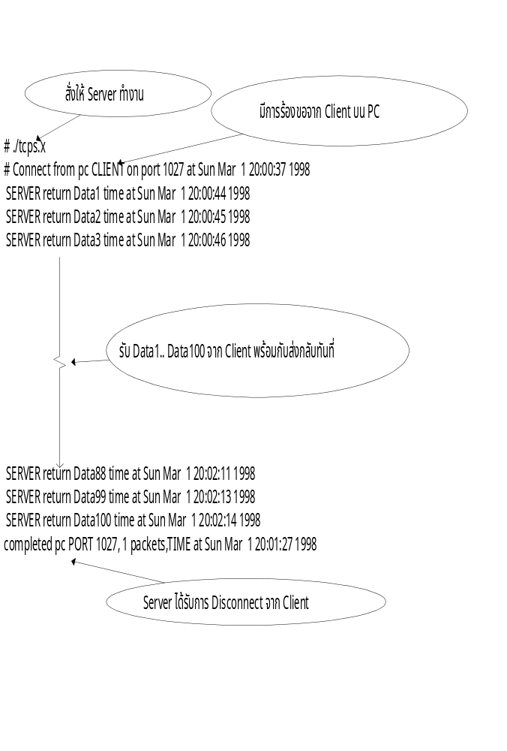

4.7.4 ผลลัพธ์การทำงานของ UDP Server บน Unix ที่เชื่อมต่อกับ UDP Client บน PC

